Additional Resources for Spinal Cord Injured Individuals

www.paralysis.org
The Reeve Foundation is dedicated to curing spinal cord injury by funding innovative research, and improving the quality of life for people living with paralysis through grants, information and advocacy.

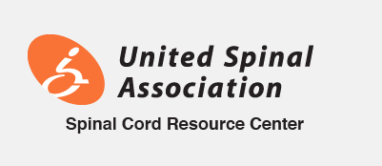
www.spinalcord.org
United Spinal Association is dedicated to enhancing the quality of life of all people living with spinal cord injuries and disorders (SCI/D), including veterans, and providing support and information to loved ones, care providers and professionals.

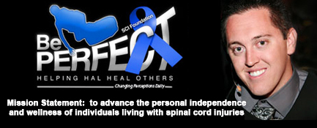
www.beperfectfoundation.com
“To restore hope, expand knowledge, advance personal independence and wellness of individuals with spinal cord injuries by promoting a holistic, exercise-based therapy approach towards a healthier recovery.”

www.triumph-foundation.org
The cornerstone of our outreach is giving newly injured people Care Baskets that are like tool-kits which provide information and resources about the many organizations, assistance programs, and activities that exist to help people with an SCI with their new beginning and to enable them to keep living their lives to the fullest potential.

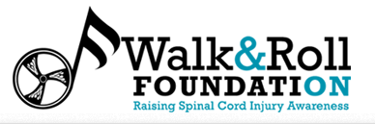
www.walkandrollfoundation.org
The Walk and Roll Foundation believes every person living with a disability should have an opportunity to turn limitations into opportunities. To do so, we have made it our mission to: Educate parents and teenagers on distracted driving, acceptance of others and making healthy and positive choices through our Distinguished Speaker Program. Inspire those with a different ability to recreate their dreams and live full lives, through our Wheelchair Dance Team performances, support groups and mentoring. Provide advice and resources to help improve the quality of life for persons affected by a disability and their families. Give individuals, with a disability, the chance to receive the semi-annual Chelsie Hill Grant award.

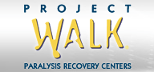
www.projectwalk.com
Project Walk is the pioneer in activity-based recovery and has been treating people living with paralysis for nearly two decades. Our Certified Recovery Specialists treat tens of thousands of client hours each year with amazing results. It is this knowledge and experience that makes our program unlike any other recovery center in the world.


www.mobilityworks.com
MobilityWorks is a national chain of wheelchair accessible van providers - serving the disabled community with wheelchair accessible minivans, full-size vans with lifts and commercial fleet vehicles.


www.wheelchairathletics.org
"The purpose of the Wheelchair Athletics Foundation is to provide and support the wheelchair athletics experience through activities that are open to any child, adult, or veteran with the hope of providing both physical and psychological therapeutic value to that person."


www.braunability.com
Over the past four decades, BraunAbility products have revolutionized what independence means to wheelchair users.

